# Opening a New Project in Visual C++ 2010

An empty project works fine for all of the exercises in this class.

File/New/Project…/Empty Project/ (Name: Day1) (Location: C:/cpp_7_2012)

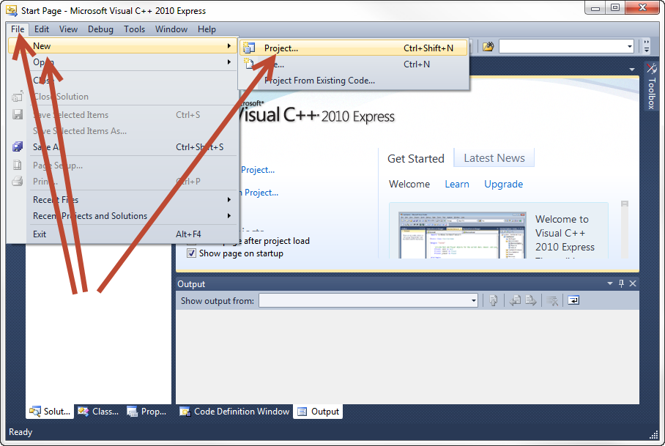

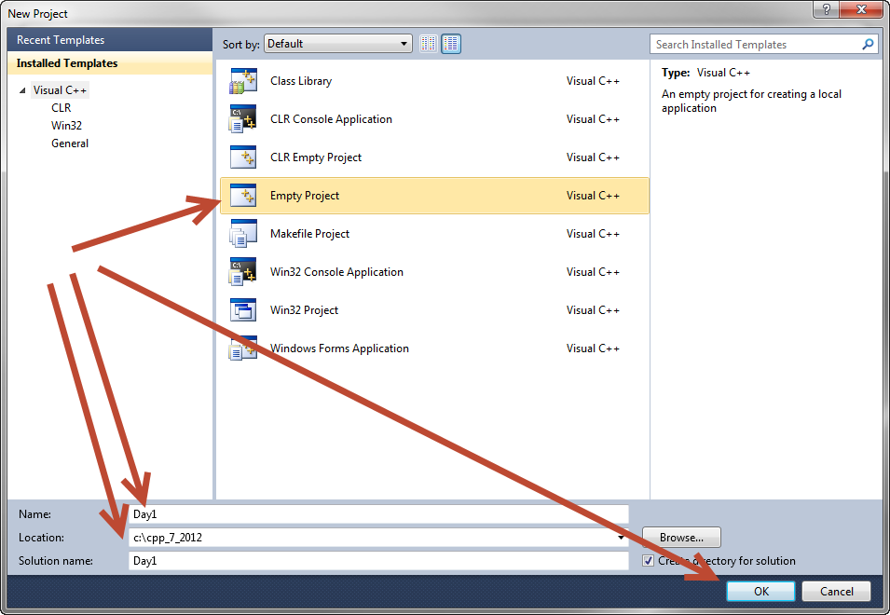

Add a “main” source file to the project. Right click on “Source Files”.

Source Files/Add/New Item…/C++ File/ (Name: one.cpp)

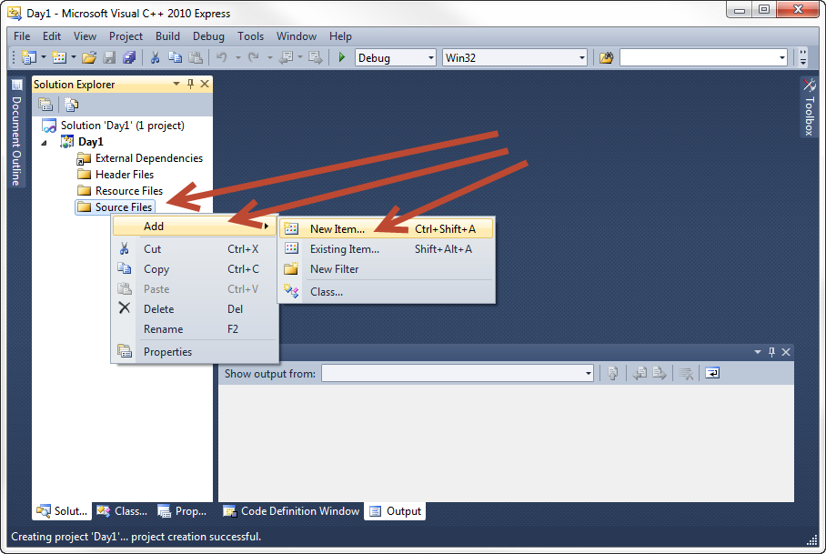

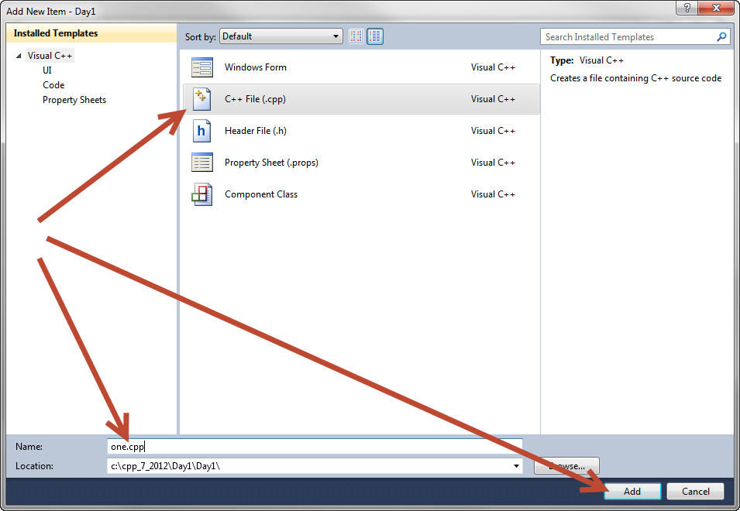

Turn on line numbering and advanced options.

Tools/Settings/Expert Settings

Tools/Options/Text Editor/C_C++/Line numbers

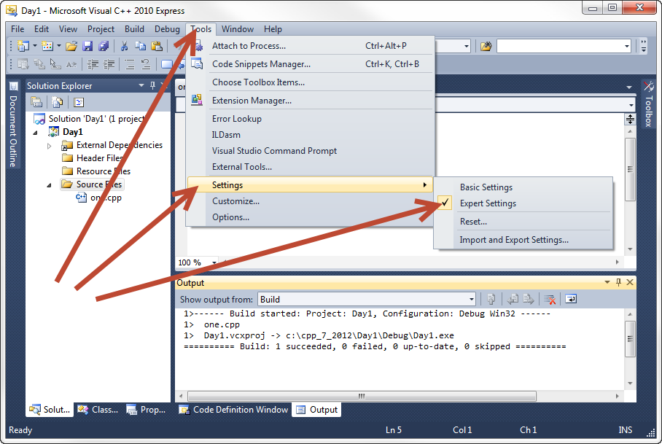

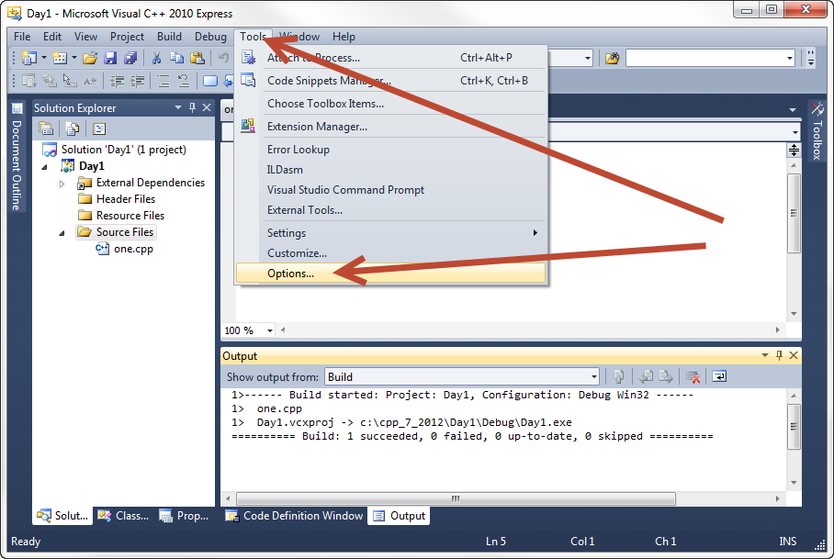

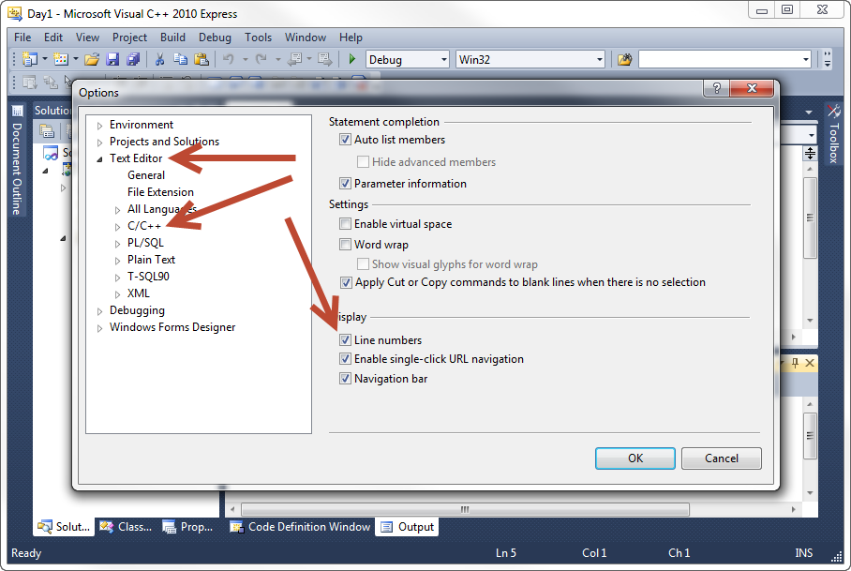

Hello World

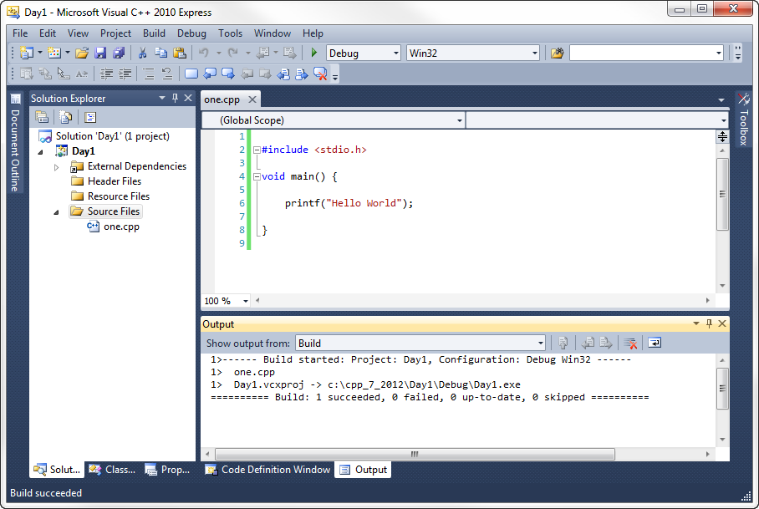

# Visual C++ Keyboard Shortcuts

F7 Build

Shift-F5 Run without debugging

F5 Debug/continue

Shift-F5 Stop debugging

F10 Step over

F11 Step into

Right-click on line to add/remove breakpoint

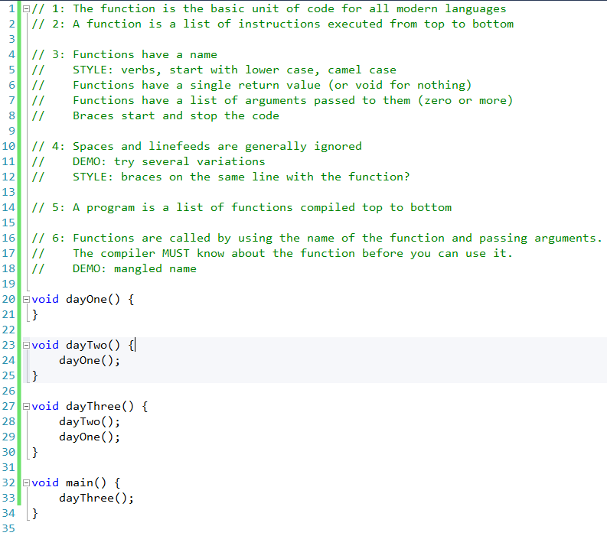

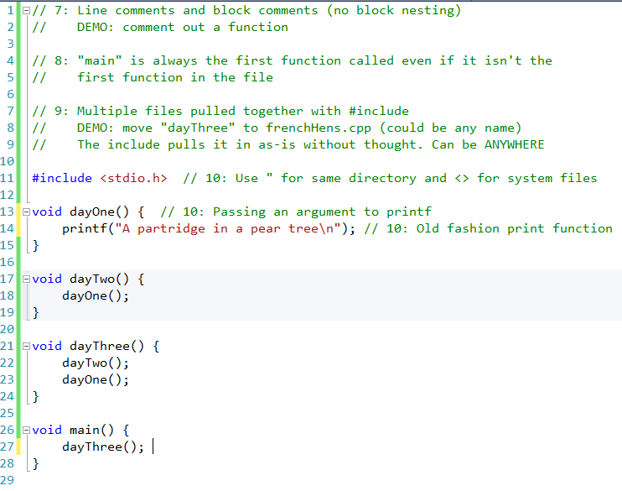

Includes are pure text-substitution. Nothing else. Nothing fancy. Can be any file (even binary). Pulled in in-place.

QUIZ: What is printed on the screen?

F7 to build. No errors. Shift-F5 to run without debugging. Too quick to see.

Launch with Explorer.

Put breakpoint and F5. Step in, step over.

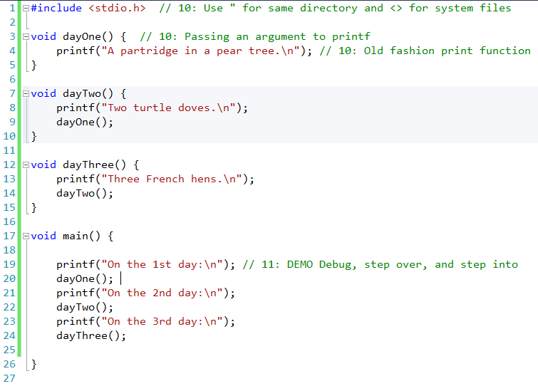

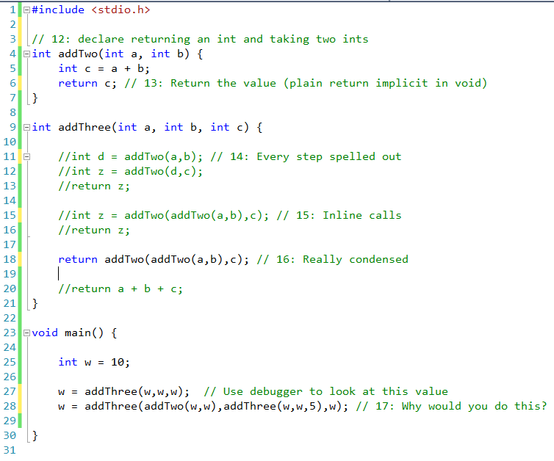

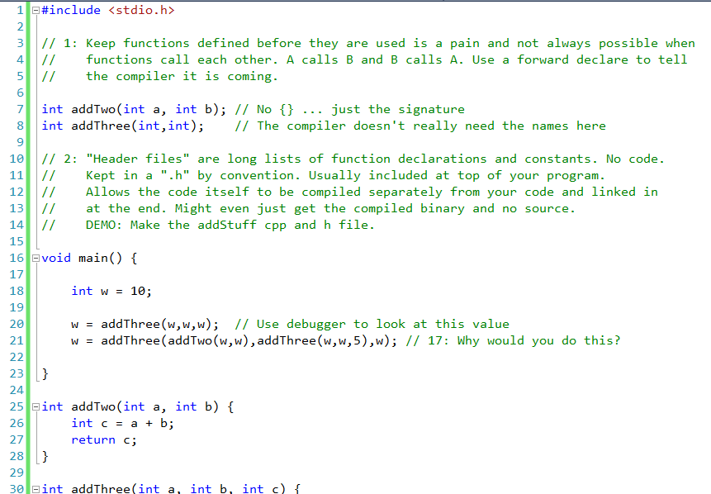

Include the .h in the .cpp if nothing else but to make sure they are in sync. If one changes and the other doesn’t then it breaks at compile.

Discuss recompiling only what is needed and buying binary libraries in detail.

